Analysis of Building Frames (Using Kani’s Method)
Gasper Kani, a German engineer, developed another distribution procedure based on slope deflection equations. This method is very useful for the analysis of multistorey frames. The greatest advantage of this method is, even if a mistake is committed in distribution in one of the cycles, it converges finally to the correct answer. Even today, many practising engineers who are not familiar with computer methods, use Kani's method for the analysis of 3 to 4 storey building frames.
This method is first explained for structures with fixed ends. Then, the modifications to handle simply supported and overhanging ends are discussed. Analysis of symmetric frames making use of the symmetry is also explained, after which an analysis of general frames is taken up.
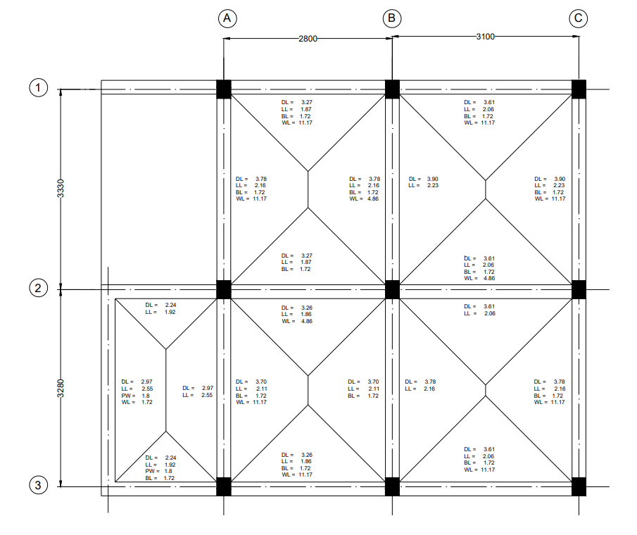
Figure 1: Beam Layout
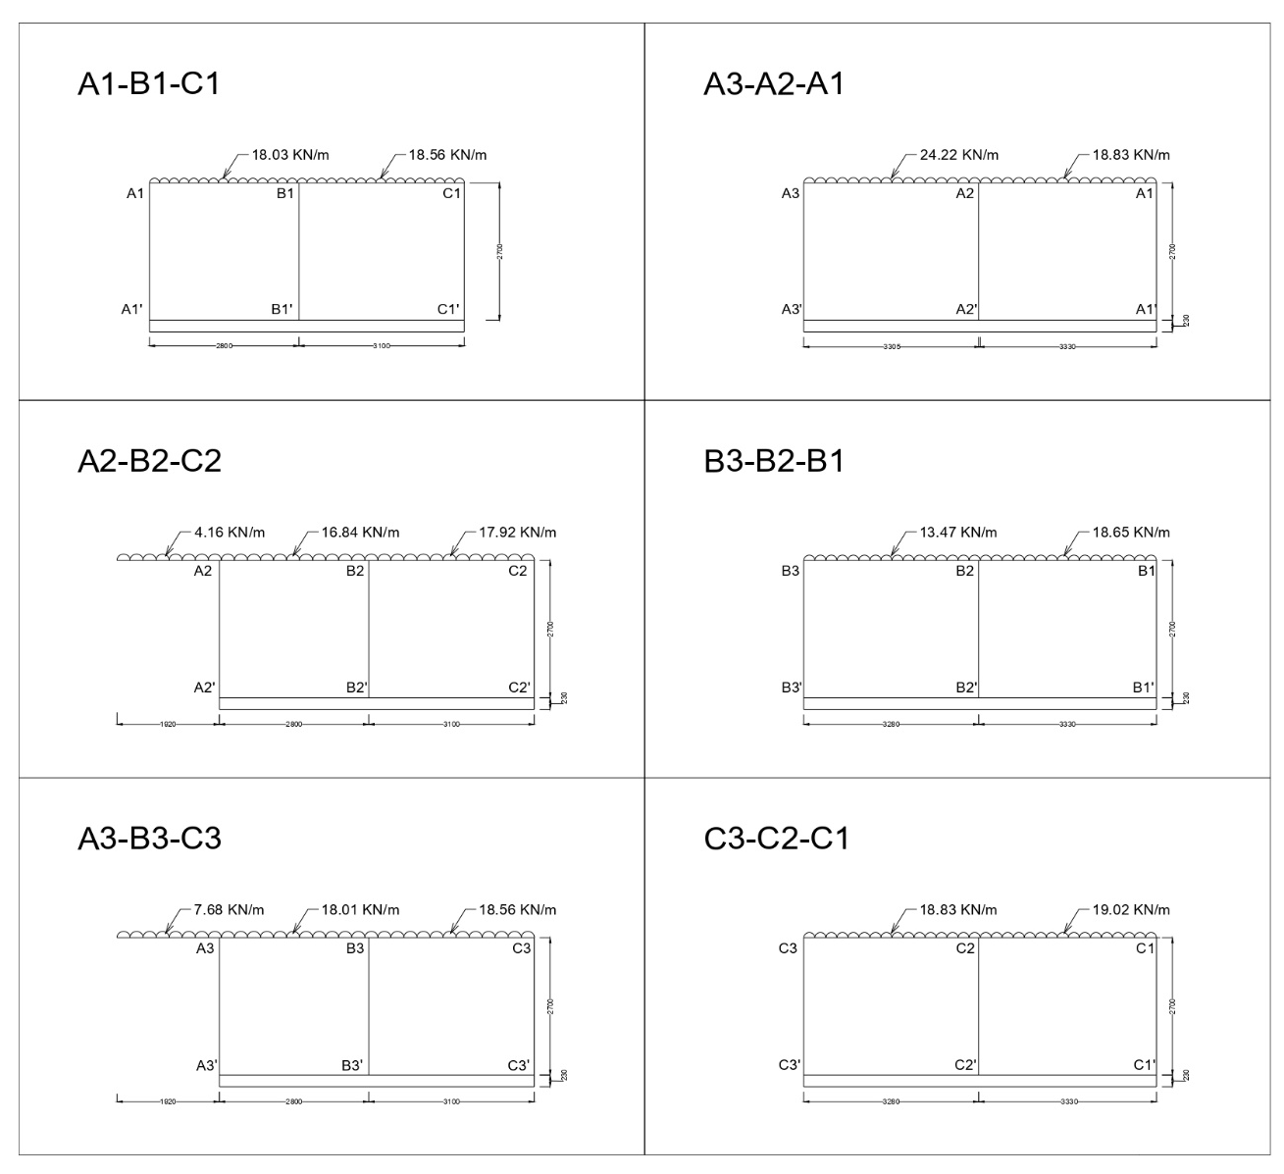
Figure 2: Frames.

Analysis of Frame A3-B3-C3
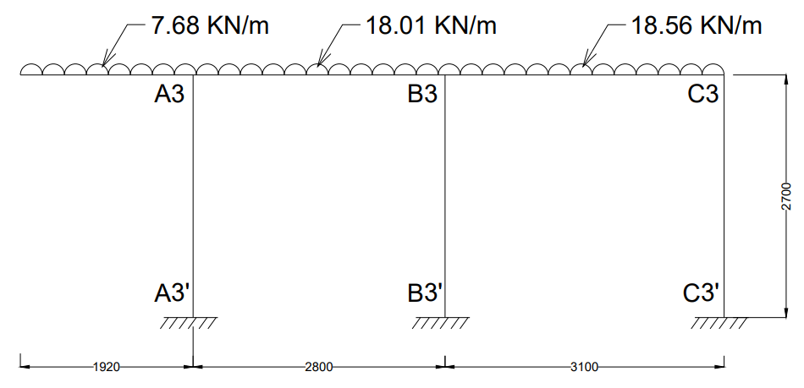
Step 1: Fixed End Moments
MF_{Overhanging} = = = 14.16 KN-m
MF_{A3B3} = = = -11.77 KN-m
MF_{B3A3} = = = +11.77 KN-m
MF_{B3C3} = = = -14.86 KN-m
MF_{C3B3} = = = +14.86 KN-m
Fixed end moments in All the columns are zero.
i.e,
MF_{A3A3՛ =} MF_{A3՛A3} = MF_{B3B3՛ =} MF_{B3՛B3 =} MF_{C3C3՛ =} MF_{C3՛C3} = 0

Step 2: Rotation Factor ,
Joints | Members | Stiffness () |  | R.F
A3 | A3B3 | 1.428EI | 2.909EI | -0.245
A3 | A3A3՛ | 1.481EI | 2.909EI | -0.255
B3 | B3A3 | 1.428EI | 4.200EI | -0.170
B3 | B3C3 | 1.290EI | 4.200EI | -0.154
B3 | B3B3՛ | 1.481EI | 4.200EI | -0.176
C3 | C3B3 | 1.290EI | 2.771EI | -0.233
C3 | C3C3՛ | 1.481EI | 2.771EI | -0.267

Stiffness ()
K_{A3B3} = = 1.428EI
K_{A3A3՛} = = 1.481EI
K_{B3A3} = = 1.428EI
K_{B3C3} = = 1.290EI
K_{B3B3՛} = = 1.481EI
K_{C3B3} = = 1.290EI
K_{C3C3՛} = = 1.481EI
Sum of Stiffness ∑ at Joints
A3: 1.428EI + 1.481EI = 2.909EI
B3: 1.428EI + 1.290EI + 1.481EI = 4.200EI
C3: 1.290EI + 1.481EI = 2.771EI
Rotation Factor
R.F_{A3B3} = = -0.245
R.F_{A3A3՛} = = -0.255
R.F_{B3A3} = = -0.170
R.F_{B3C3} = = -0.154
R.F_{B3B3՛} = = -0.176
R.F_{C3B3} = = -0.233
R.F_{C3C3՛} = = -0.267

Step 3: Displacement Factor
Storey | Members |  |  | D.F
1 | A3A3՛ | 1.481EI | 4.444EI | -0.5
1 | B3B3՛ | 1.481EI | 4.444EI | -0.5
1 | C3C3՛ | 1.481EI | 4.444EI | -0.5

Stiffness ()
K_{A3A3՛} = = 1.481EI
K_{B3B3՛} = = 1.481EI
K_{C3C3՛} = = 1.481EI
Sum of Stiffness ∑ at Storey
∑ = 1.481EI + 1.481EI + 1.481EI = 4.444EI
Displacement Factor
D.F_{A3A3՛} = = -0.5
D.F_{B3B3՛} = = -0.5
D.F_{C3C3՛} = = -0.5

Rotation and Displacement Contribution
starting FEM at Joint A3 ∑FEM will be the sum of the overhang and the beam:
∑FEM_{A3} = 14.16 + (-11.77) = 2.39KN-m
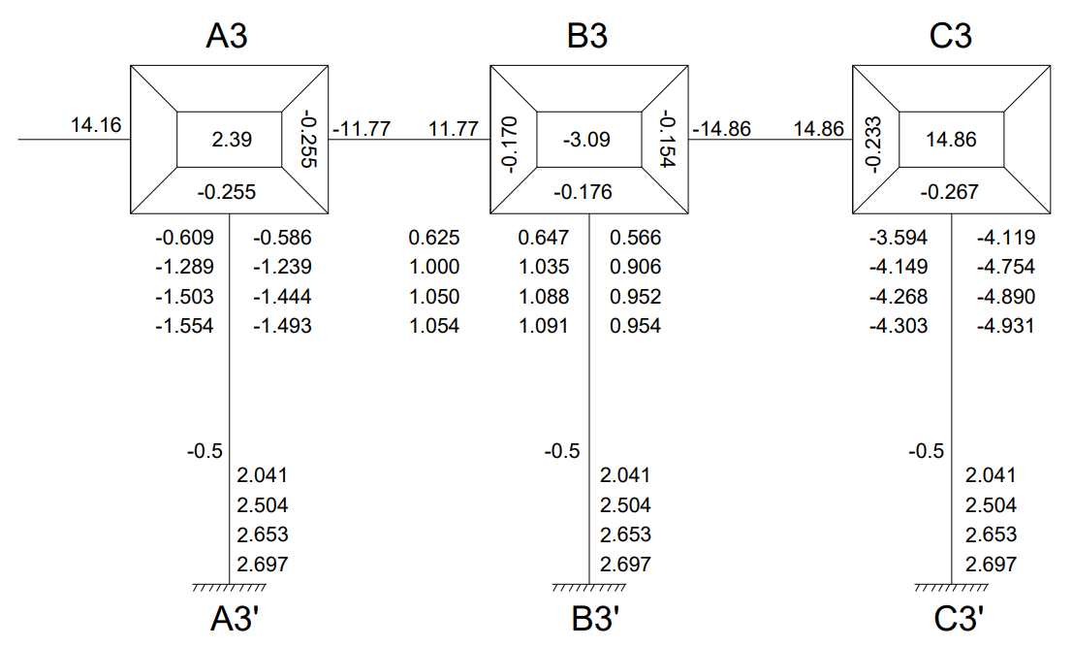

Cycle 1
Joint Rotation
M_{A3B3} = -0.245 × [2.39 + 0 + 0] = -0.586
M_{A3A3՛} = -0.255 × [2.39+ 0 + 0] = -0.609
M_{B3A3} = -0.170 × [-3.09 + (-0.586) + 0] = 0.625
M_{B3C3} = -0.154 × [-3.09 + (-0.586) + 0] = 0.566
M_{B3B3՛} = -0.176 × [-3.09 + (-0.586) + 0] = 0.647
M_{C3B3} = -0.233 × [14.86 + 0.566 + 0] = -3.594
M_{C3C3՛} = -0.267 × [14.86 + 0.566 + 0] = -4.119
Displacement Contribution
For All Columns
M_{A3A3՛} + M_{B3B3՛} + M_{C3C3՛} = -0.5 (-0.609 + 0.647 + (-4.119)) = 2.041

Cycle 2
Joint Rotation
M_{A3B3} = -0.245 × [2.39 + 2.041 + 0.625] = -1.239
M_{A3A3՛} = -0.255 × [2.39 + 2.041 + 0.625] = -1.289
M_{B3A3} = -0.170 × [-3.09 + 2.041 + (-1.239) + (-3.594)] = 1.000
M_{B3C3} = -0.154 × [-3.09 + 2.041 + (-1.239) + (-3.594)] = 0.906
M_{B3B3՛} = -0.176 × [-3.09 + 2.041 + (-1.239) + (-3.594)] = 1.035
M_{C3B3} = -0.233 × [14.86 + 2.041 + 0.906] = -4.149
M_{C3C3՛} = -0.267 × [14.86 + 2.041 + 0.906] = -4.754
Displacement Contribution
For All Columns
M_{A3A3՛} + M_{B3B3՛} + M_{C3C3՛} = -0.5 (-1.289 + 1.035 + (-4.754)) = 2.504

Cycle 3
Joint Rotation
M_{A3B3} = -0.245 × [2.39 + 2.504 + 1.000] = -1.444
M_{A3A3՛} = -0.255 × [2.39 + 2.504 + 1.000] = -1.503
M_{B3A3} = -0.170 × [-3.09 + 2.504 + (-1.444) + (-4.149)] = 1.050
M_{B3C3} = -0.154 × [-3.09 + 2.504 + (-1.444) + (-4.149)] = 0.952
M_{B3B3՛} = -0.176 × [-3.09 + 2.504 + (-1.444) + (-4.149)] = 1.088
M_{C3B3} = -0.233 × [14.86 + 2.504 + 0.952] = -4.268
M_{C3C3՛} = -0.267 × [14.86 + 2.504 + 0.952] = -4.890
Displacement Contribution
For All Columns
M_{A3A3՛} + M_{B3B3՛} + M_{C3C3՛} = -0.5 (-1.503 + 1.088 + (-4.890)) = 2.653

Cycle 4
Joint Rotation
M_{A3B3} = -0.245 × [2.39 + 2.653 + 1.050] = -1.493
M_{A3A3՛} = -0.255 × [2.39 + 2.653 + 1.050] = -1.554
M_{B3A3} = -0.170 × [-3.09 + 2.653 + (-1.493) + (-4.268)] = 1.054
M_{B3C3} = -0.154 × [-3.09 + 2.653 + (-1.493) + (-4.268)] = 0.954
M_{B3B3՛} = -0.176 × [-3.09 + 2.653 + (-1.493) + (-4.268)] = 1.091
M_{C3B3} = -0.233 × [14.86 + 2.653 + 0.954] = -4.303
M_{C3C3՛} = -0.267 × [14.86 + 2.653 + 0.954] = -4.931
Displacement Contribution
For All Columns
M_{A3A3՛} + M_{B3B3՛} + M_{C3C3՛} = -0.5 (-1.554 + 1.091 + (-4.931)) = 2.697

Step 4: Final End Moments
M_{ij} = FEM + 2×M_{ij} (Near end Rotation) + M_{ji} (Far end Rotation) +M՛՛ (Displacement)
Beams (No Sway M՛՛= 0) “for Joint A3, the Overhang Moment is a fixed constant of +14.16 KN-m”
M_{A3B3} = -11.77 + 2(-1.493) + 1.054 = -13.70 KN-m
M_{B3A3} = 11.77 + 2(1.054) + (-1.493) = 12.39 KN-m
M_{B3C3} = -14.86+ 2(0.954) + (-4.303) = -17.26 KN-m
M_{C3B3} = 14.86 + 2(-4.303) + 0.954 = 7.21 KN-m
Column (With Sway M՛՛= 2.697)
M_{A3A3՛} = 0 + 2(-1.554) + 0 + 2.697 = -0.41 KN-m
M_{A3՛A3} = 0 + 2(0) + (-1.554) + 2.697 = 1.14 KN-m
M_{B3B3՛} = 0 + 2(1.091) + 0 + 2.697 = 4.88 KN-m
M_{B3՛B3} = 0 + 2(0) + 1.091 + 2.697 = 3.79 KN-m
M_{C3C3՛} = 0 + 2(-4.931) + 0 + 2.697 = -7.17 KN-m
M_{C3՛C3} = 0 + 2(0) + (-4.931) + 2.697 = -2.23 KN-m
Equilibrium Check
“To check Joint A3, we must include that +14.16 overhanging moment along with the beam and column.”
Joint A3 = M_{overhanging} + M_{A3B3} + M_{A3A3՛} = 14.16 + (-13.70) + (-0.41) = 0.05 ≈ 0
Joint B3 = M_{B3A3} + M_{B3C3՛ +} M_{B3B3՛} = 12.39 + (-17.26) + 4.88 = 0.01 ≈ 0
Joint C3 = M_{C3B3} + M_{C3C3՛} = 7.21 + (-7.17) = 0.04 ≈ 0
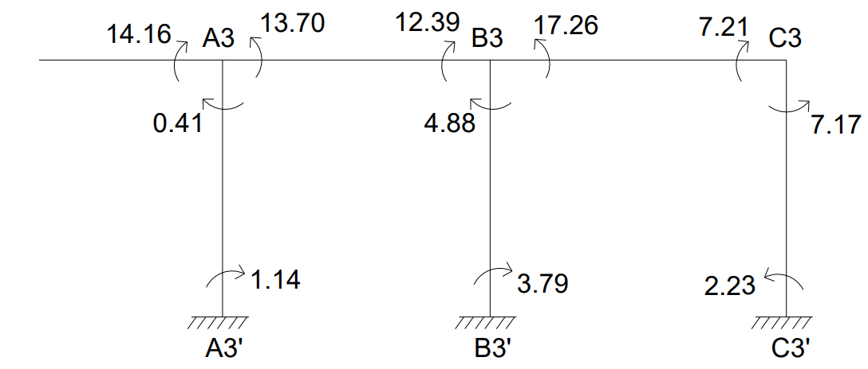
CALCULATION BENDING MOMENT
“Since the overhang is a cantilever, it doesn't have a simply supported "sagging" mid-span moment. Its moment is purely negative (hogging), starting at 0 at the free end and curving to 14.16 KN-m at support A3.”
BM_{A3B3} = = = 17.65KN-m
BM_{B3C3} = = = 22.30KN-m
BENDING MOMENT DIAGRAM
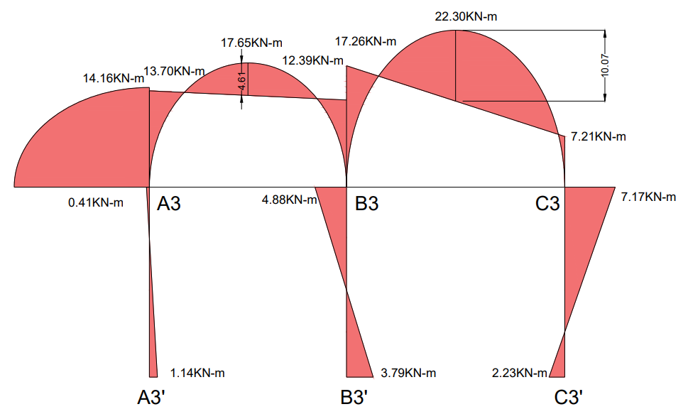
CALCULATION OF REACTIONS

From Overhang (Direct load transfer):
R_{overhang} = w × L = 7.68 × 1.92 = 14.75KN
For Span A3B3
Simply Supported Reactions:
R_{total} @ A3B3= = = 25.21KN
Reaction Due to End Moments: (Net clockwise moment means left support gets less load)
R_{moment} @ A3B3= = = +0.47KN
Reaction Due to End Moments: (Net clockwise moment means right support gets more load)
R_{moment} @ A3B3= = = -0.47KN

For Span B3C3
Simply Supported Reactions:
R_{total} @ B3C3 = = = 28.77KN
Reaction Due to End Moments: (Net clockwise moment means left support gets more load)
R_{moment} @ B3C3= = = +3.24KN
Reaction Due to End Moments: (Net clockwise moment means right support gets less load)
R_{moment} @ B3C3= = = -3.24KN
Final Reactions:
R_{A3} = R_{overhang} + R_{total} @ A3B3 + R_{moments} @ A3B3_{(Left Support)}
R_{A3} = 14.75 + 25.21 + 0.47 = 40.43KN
R _{B3} = (R_{total} @ A3B3+ R_{moments} @ A3B3_{(Right Support)}) + (R_{total} @ B3C3+ R_{moments} @ B3C3_{(Left Support)}) =
R _{B3} = (25.21 + (-0.47)) + (28.77 + 3.24) = 56.75KN
R _{C3} = R_{total} @ B3C3+ R_{moments} @ B3C3_{(Right Support)} =
R _{C3} = 28.77 + (-3.24) = 25.53KN
